Course Code: CSA1557

Course Name: Cloud Computing and Big Data Analytics

RISSHITH BS 192210021

1) Create a simple cloud software application for Flight Reservation System using any Cloud Service Provider to demonstrate SaaS include the necessary fields such as one way, round trip, From, to, Departure, Departure, Travelers & Class, Fare Type, International and Domestic Flights etc.

AIM: To create a simple cloud software application for flight reservation system using any cloud service provider to demonstrate saas.

PROCEDURE:

Step1: Go to zoho.com.

Step 2: Log into the zoho.com.

Step 3: Select one application step.

Step4: Enter application name as flight reservation system.

Step 5: Created new application flight reservation system.

Step 6: Select one form

Step 7: The software has been created.

IMPLEMENTATION:

STEP1: GOTO ZOHO.COM

STEP 2: LOGINTOTHE ZOHO.COM

STEP 3: SELECT ONE APPLICATION

STEP 4: ENTER APPLICATION NAME

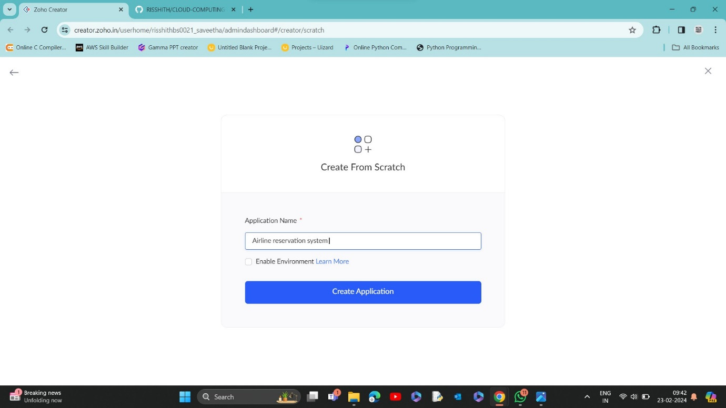

STEP 5: CREATED NEW APPLICATION

STEP 6: SELECT FROM SCRATCH

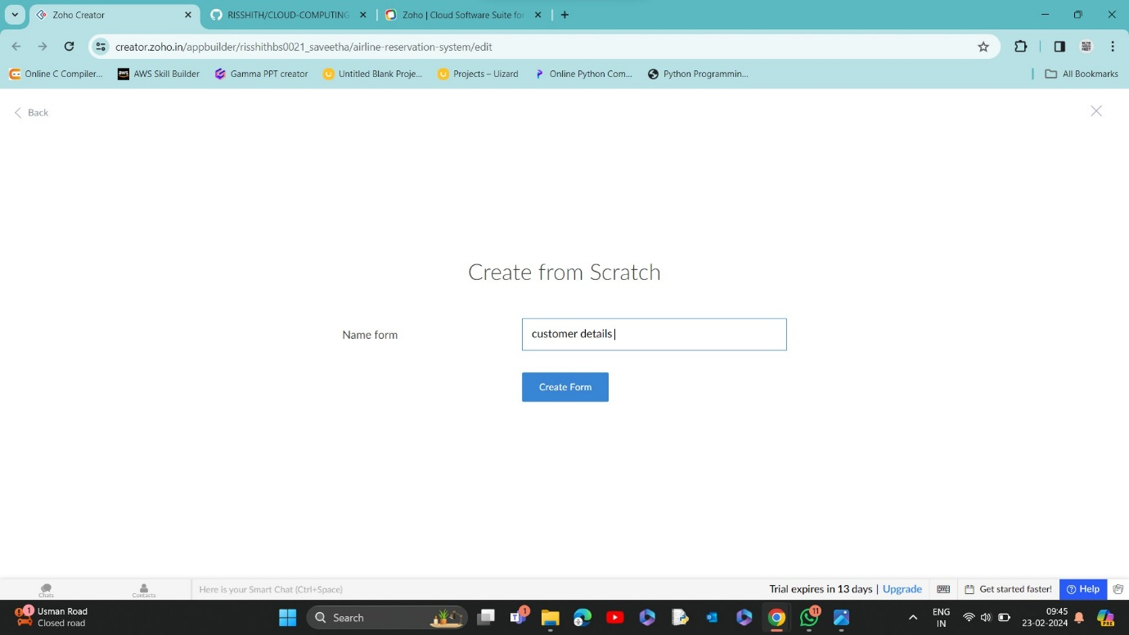

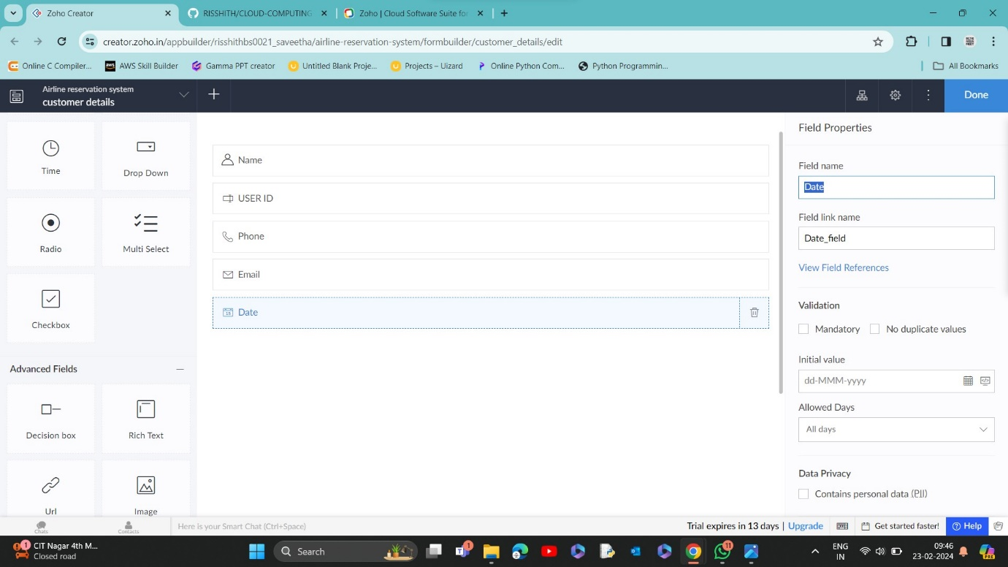

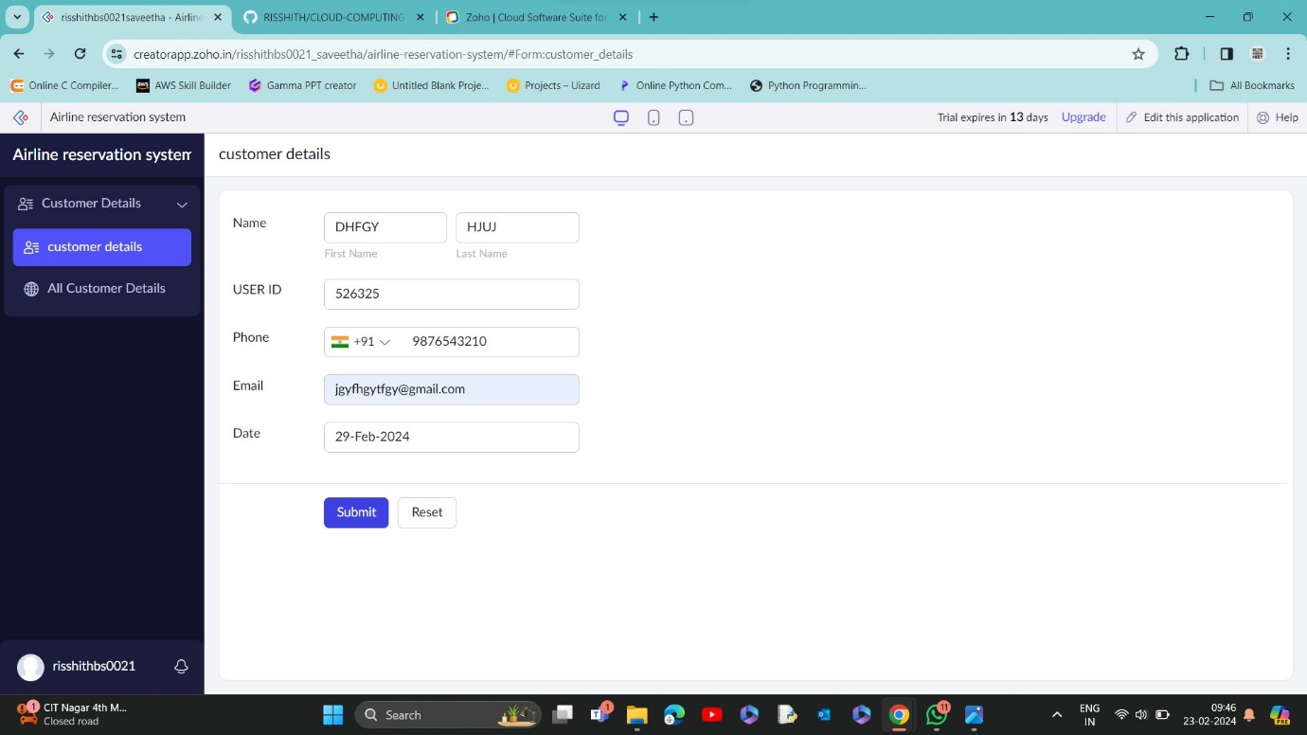

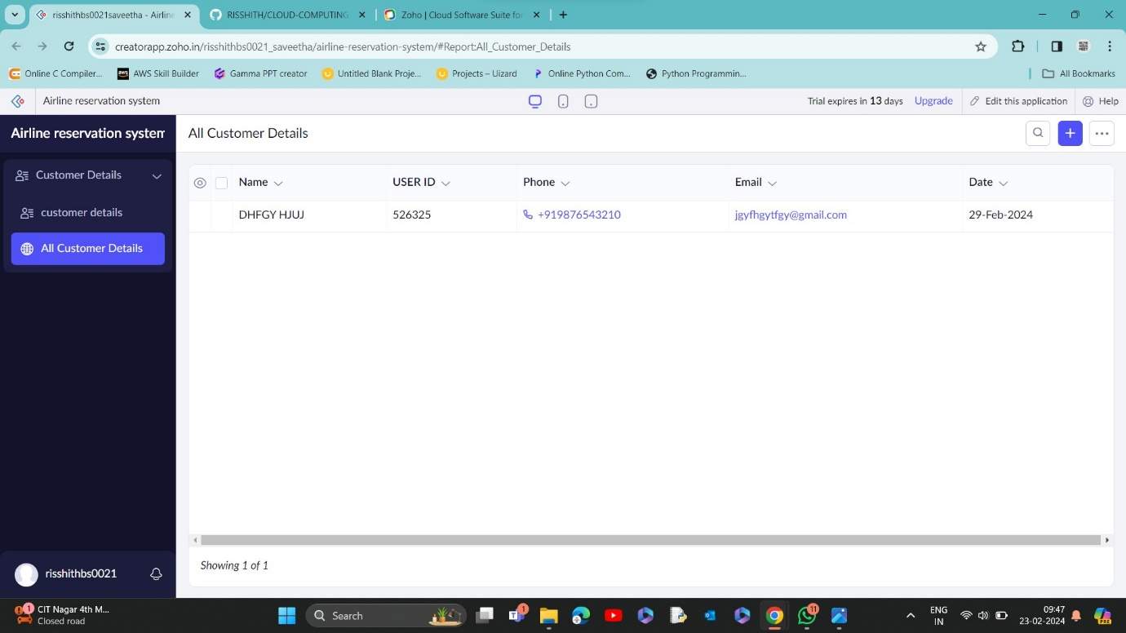

STEP 7: CREATE FORM AS BOOKING DETAILS.

STEP 8: THE FORM HAS BEEN CREATED AS LOGIN AND CHOOSE THE FIELDS IN BOOKING DETAILS

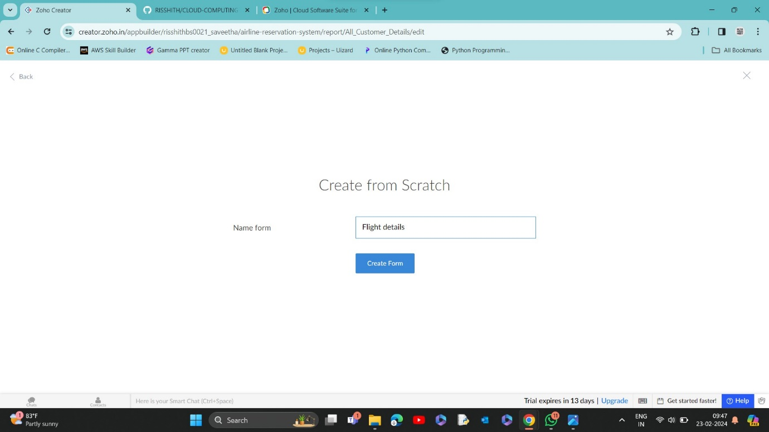

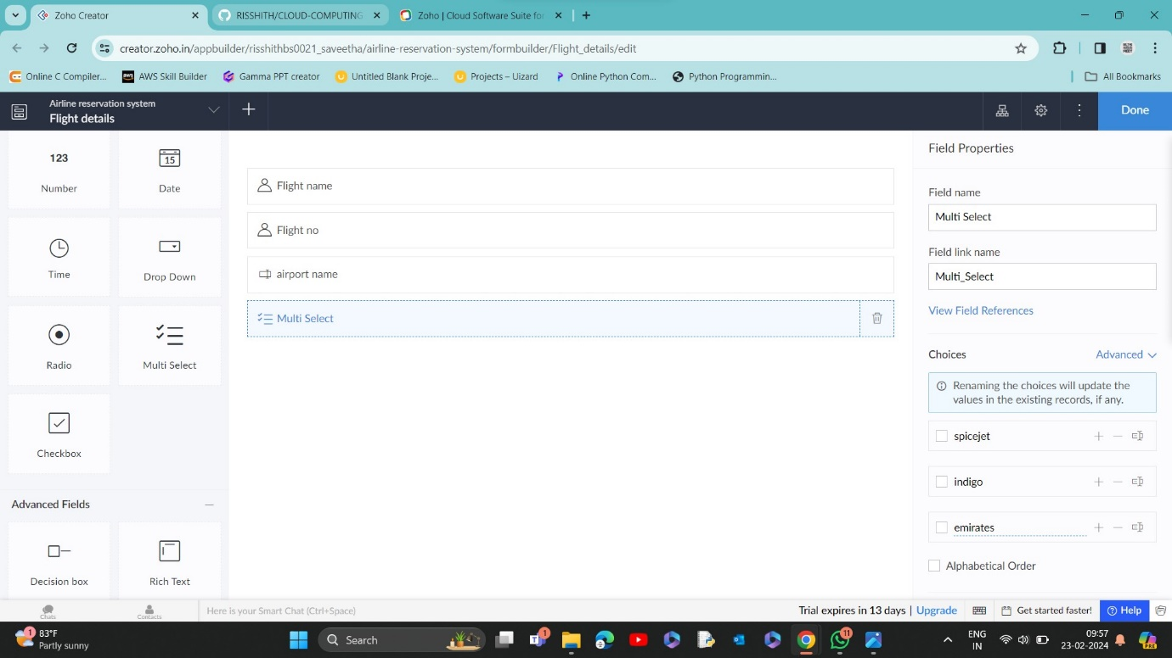

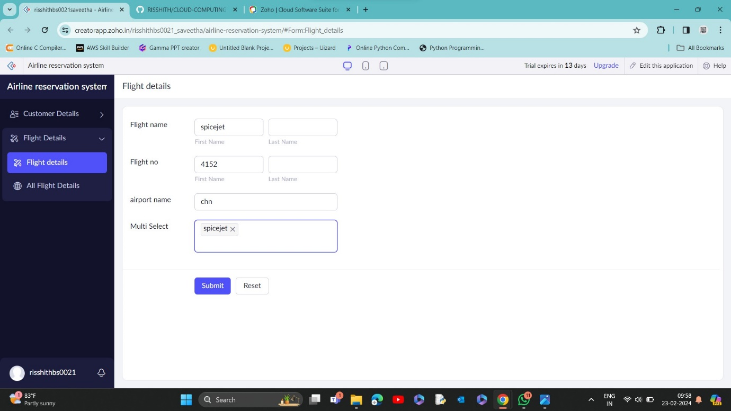

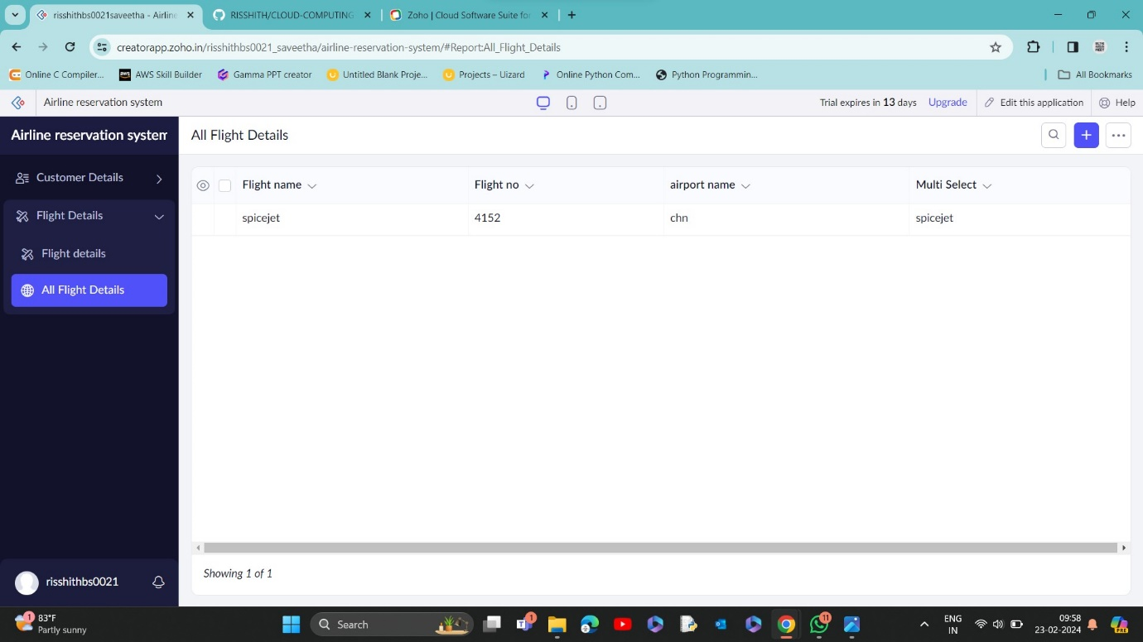

STEP 9: CREATE NEW FORM AS BOOKING DETAILS

